

FACULTY OF TECHNOLOGY AND ENGINEERING
DEVANG PATEL INSTITUTE OF ADVANCED TECHNOLOGY AND RESEARCH

DEPARTMENT OF INFORMATION TECHNOLOGY

A.Y 2026-27 Semester-3

LAB MANUAL

CSUC201: Fundamentals of Data Structure and Algorithms



Practical 5
Practical AIM:
To implement core doubly linked list and circular linked list operations and understand how bidirectional and circular linking change the way nodes are inserted, deleted, and traversed.
Practical 5.1
Problem Definition:
A music player maintains a playlist where songs can be added to the beginning, added to the end, or inserted right after a specific song that is currently playing. When a song is removed, only the first song in the playlist is dropped. At any point the player can count how many songs are in the playlist and display them from first to last. Given a sequence of such operations, implement all of them on a doubly linked playlist and print the result after each operation.
Describe how your insertion after a given song works. What extra step does a doubly linked list require here that a singly linked list did not? What happens if the given song is not found in the playlist?
Problem faced:
I faced difficulty while inserting a node after a specific song because both forward and backward links had to be updated correctly.
Solution:
I used a temporary pointer temp to find the given song. Then I created a new node and adjusted the links using newNode->next = temp->next and newNode->prev = temp. I also updated the next node's prev link and temp->next to connect the new node correctly. If the given song was not found, no insertion was performed.
Output:
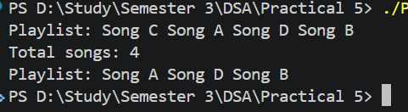
Practical 5.2
Problem Definition:
A group of students are sitting in a circle playing a passing game. A token starts at the first student and is passed around the circle one student at a time. Students can join the circle at any position and leave at any time, and the circle must remain unbroken after every join or leave. Given a sequence of join, leave, and display operations, implement them on both a singly circular and a doubly circular linked list and print the current circle after each operation.
Describe how your solution ensures the circle stays unbroken after a student leaves. What is the one case where breaking the circle is most likely to happen as a bug, and how did you handle it?
Problem faced:
I faced difficulty while maintaining the circular connection during insertion and deletion, especially when the first or only node was involved.
Solution:
I updated the links carefully after every insertion and deletion so that the last node always points back to the first node. In the doubly circular list, I updated both next and prev links. I handled the single-node case separately by setting head to NULL when the only node was deleted.
Output:
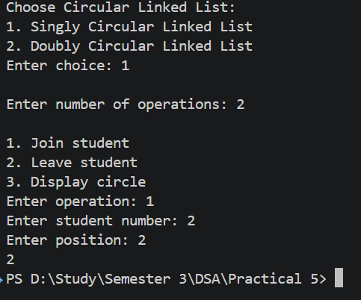
Key Questions:
1. [Problem 1] A doubly linked list maintains two links per node instead of one. When deleting the front node, explain why having a backward link on the second node creates a responsibility that did not exist in a singly linked list — and what goes wrong if you forget to handle it.
ANS:
When deleting the front node in a doubly linked list, the prev pointer of the new first node must be changed to NULL. If we forget to update it, the new first node will still point backward to the deleted node. This creates an invalid link and may cause errors when traversing the list backward.
2. [Problem 2] If your traversal of the circular list does not stop at the right moment, it will loop forever. Without referencing any specific code, explain what condition must be true at the moment you stop, and why that condition would fail if you set the last node's link to
null.
ANS:
In a circular linked list, traversal should stop when we reach the first node again. This condition shows that we have completed one full circle. If the last node's link is set to NULL, the circular connection is broken, so traversal will stop at NULL instead of returning to the first node.
Github Link:
https://github.com/dhanvi-219/FDSA/tree/main/Practical%205

